**Enerji Yönetim Sistemi (EnYS) Öneri Formu**

**(Energy Management System (EnMS) Suggestion Form)**

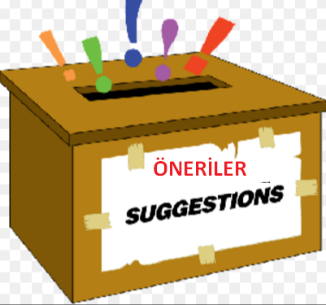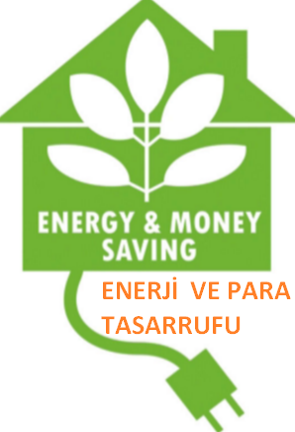

**Öneri/İstek (Suggestion/Request):** _____________________________

_______________________________________________________________

_______________________________________________________________

_______________________________________________________________

_______________________________________________________________

_______________________________________________________________

**Öneri Tarihi (Date of Suggestion):** ______________________________

**Öneren (Suggestion submitted by)**: _____________________________

**Alanı/Bölüm (Area/Department):** _______________________________

**Telefon Nosu (Phone Number):** _________________________________

**E-posta Adresi (Email Address):** ________________________________

*Enerji tasarrufu sağlamak veya enerji yönetimini iyileştirmek için bir fikriniz var mı ?*

*(Got an idea to save energy or improve energy management ?)*